6

Simpsons

User Guide

Contents

Introduction 2

Hardware and Software Requirements 2

Minimum Hardware Requirements 2

Recommended Hardware Requirements 2

Software Requirements 2

Navigation 3

Main Menu 3

Cosmetics Menu 4

Menu Strip 5

Customer Form 6

Add Customer 6

Edit Customer 9

Booking 11

Add booking 11

Edit Booking 15

Reports 17

# Introduction

This system has been designed with the requirements from Simpsons kept in mind. The intention is to make keeping track of customers and bookings as easy as possible for the user. This document includes screenshots and instructions to guide a user through the processes of this system.

# Hardware and Software Requirements

## Minimum Hardware Requirements

Processor: 1.5GHz Intel Core i3

Memory: 2GB RAM

Storage: 5GB Available Space

GPU: 128 MB DirectX 9 graphics device

## Recommended Hardware Requirements

Processor: 3GHz Intel core i5-8250U

Memory: 4GB RAM

Storage: 20GB Available Space

GPU: 128 MB DirectX 9 graphics device

## Software Requirements

Operating System: Windows 10

IDE: Visual Studio 2015 or newer

# Navigation

## Main Menu

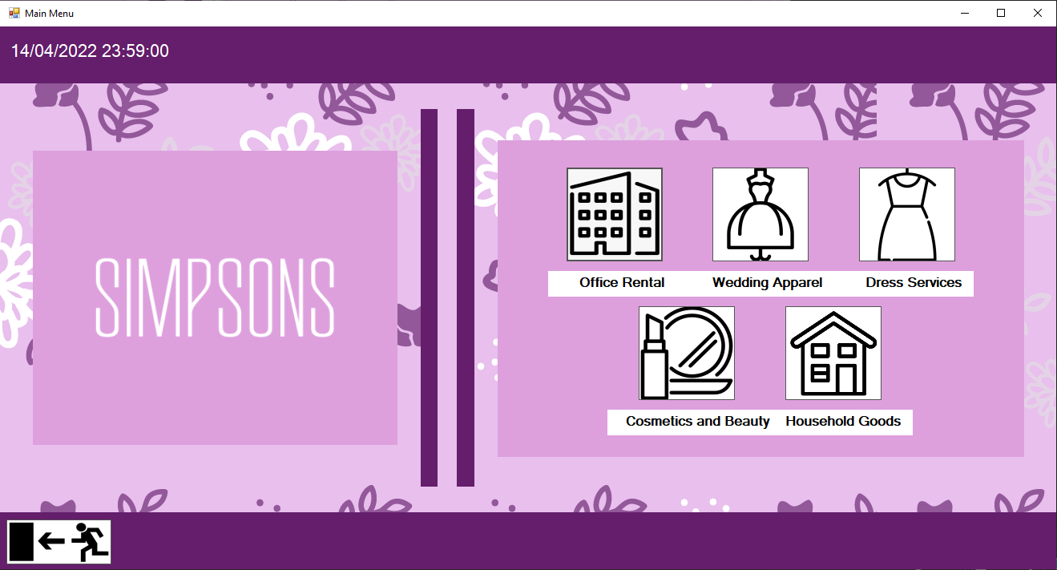

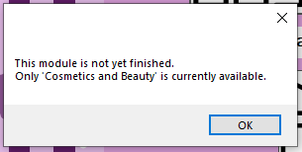Clicking the “Office Rental”, “Wedding Apparel”, “Dress Services” or “Household Goods” buttons will results in this message box appearing:

As the message box states this is because only the Cosmetics and Beauty module has been implemented so far.

“Cosmetics and Beauty” – This button will bring you to the Cosmetics Menu form.

“Exit” – In the bottom left. This will exit the program.

## Cosmetics Menu

This menu will let you navigate to each aspect of the Cosmetics and Beauty system.

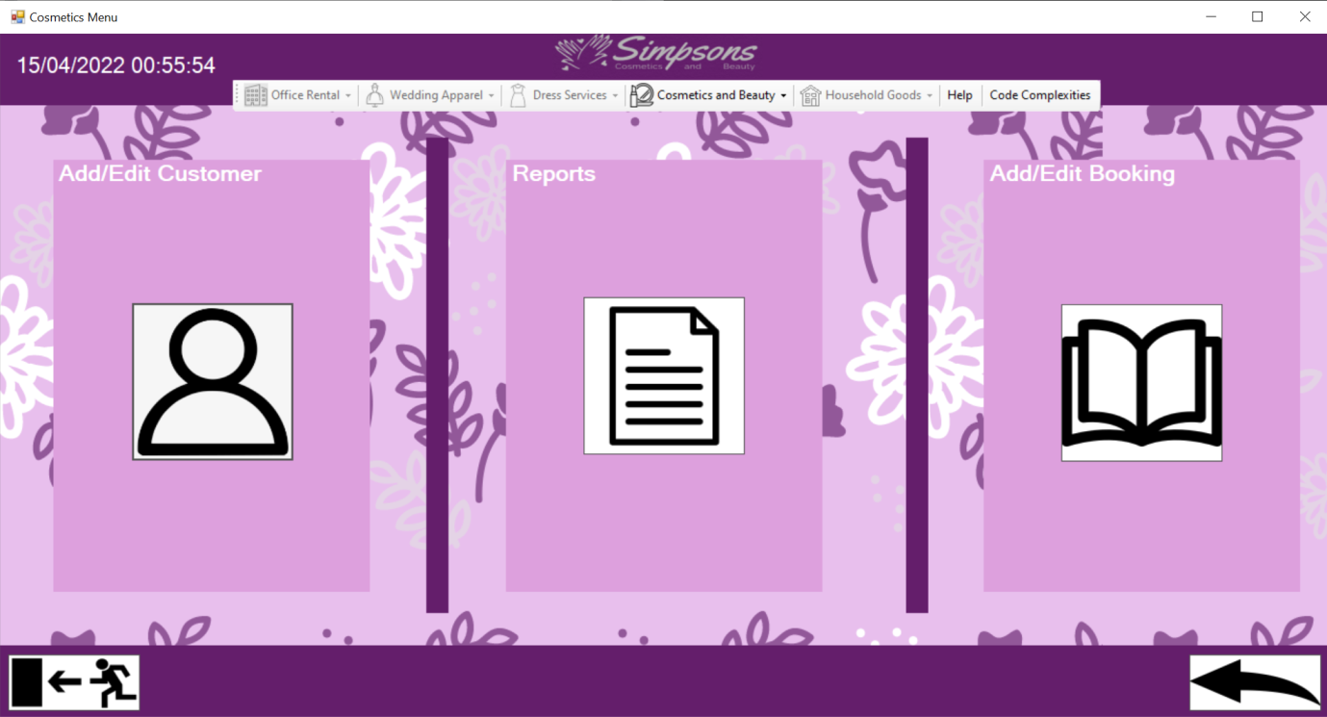

“Add/Edit Customer” – This will bring you to the customer form where you can add a new customer or edit and existing customer.

“Reports” – This will bring will bring you to the reports form where you can build a report based on a chosen customer.

“Add/Edit Booking” – This will bring you to the booking form where you can add a booking and edit an existing booking taking place at a later date.

“Back” – In the bottom right. This will return you to the main menu.

## Menu Strip

This menu strip allows for easy navigation to any part of the system without having to go through other menus.

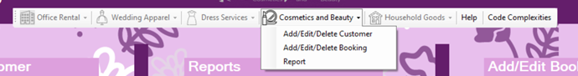

Each module that is not yet implemented is disabled.

“Cosmetics and Beauty” – This shows a drop down list of each aspect in the Cosmetics and Beauty section of the system. Clicking on each option will bring you to the respective form.

“Help” – This will open the user guide.

“Code Complexities” – This will open the code complexities document.

# Customer Form

This is the complete customer form.

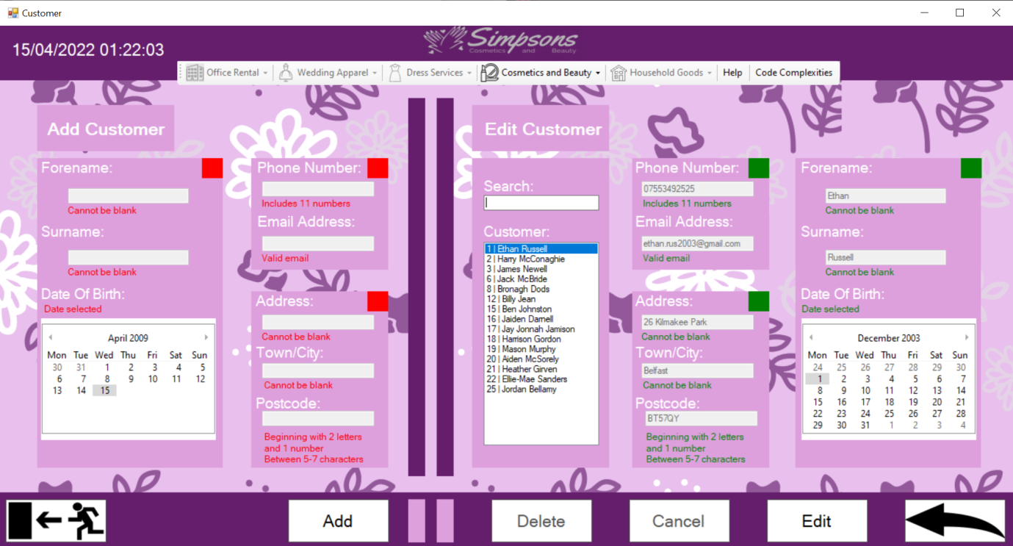

As you can see there are two sides to this form. On the left is the “Add Customer” section and to the right is the “Edit Customer” section. Click on either the “Add” button or the “Edit” button to enable the respective side and begin using the form. Or if you wish to view the details of a customer you can select the customer in the list box without having to enable the edit section.

## Add Customer

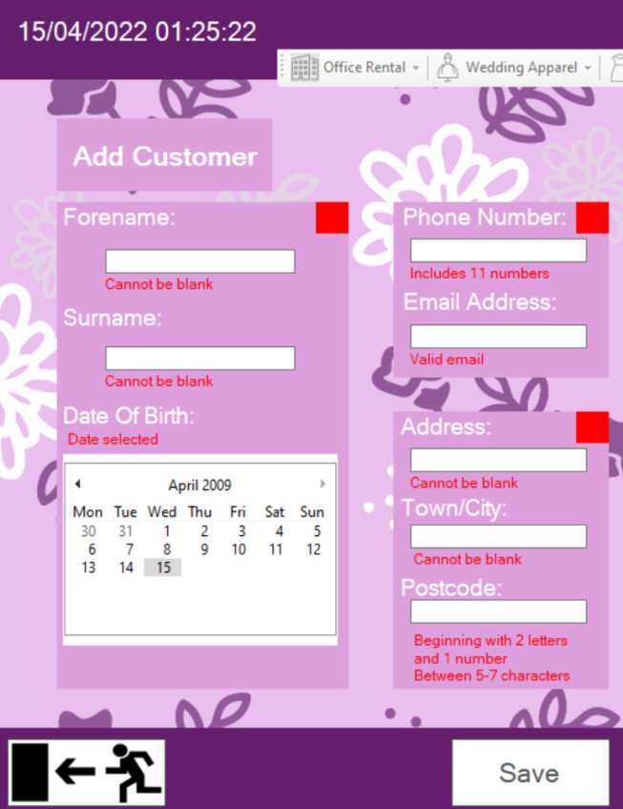This is the section in which you will enter a customer’s details to add them to the database.

At first all of the guidance labels will be highlighted red and the save button will be disabled. To enable the save button you must fill out each field. The guidance labels will specify what is required.

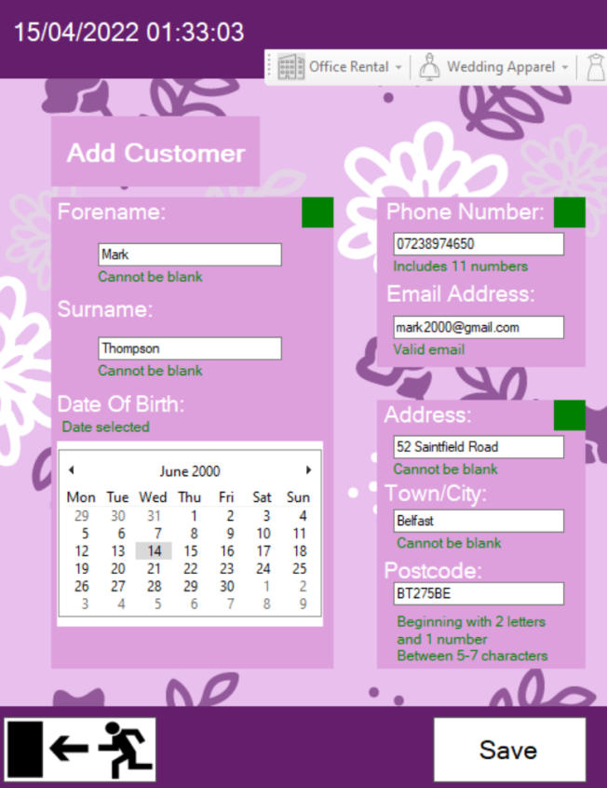

This is an example of proper data. As you can see the guidance labels are all now highlighted green. This shows that each field is filled correctly. The boxes to the top right of each block also implies that block of data is all complete.

“Forename” – Cannot contain numbers and special characters other than “-“and “.”

“Surname” – Cannot contain numbers and special characters other than “-“and “.”

“Date of Birth” – A minimum age of 13 is required

“Phone Number” –Only contains numbers and must be a length of 11 numbers

“Email Address” –Must contain an “@” symbol and a “.com” or “.co.uk”

“Address” – Cannot contain numbers and special characters other than “-“and “.”

“Town” – Cannot contain numbers and special characters other than “-“and “.”

“Postcode” –Must begin with 2 letters, followed by 1 or 2 numbers. Then it is followed by a combination of letters and or numbers. It Must be a length of 5 – 7 characters. It Does not accept spaces or special characters.

Once you are happy with your entered data you can click the save button to save the customer. A message box will appear asking you to confirm you wish to save. Click yes if you intended to save this customer’s data

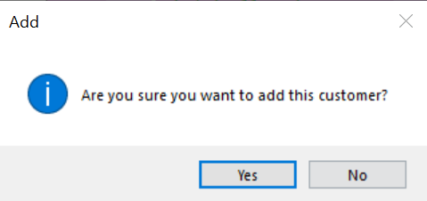

## Edit Customer

This is the section in which you can view and or edit the data of any added customer.

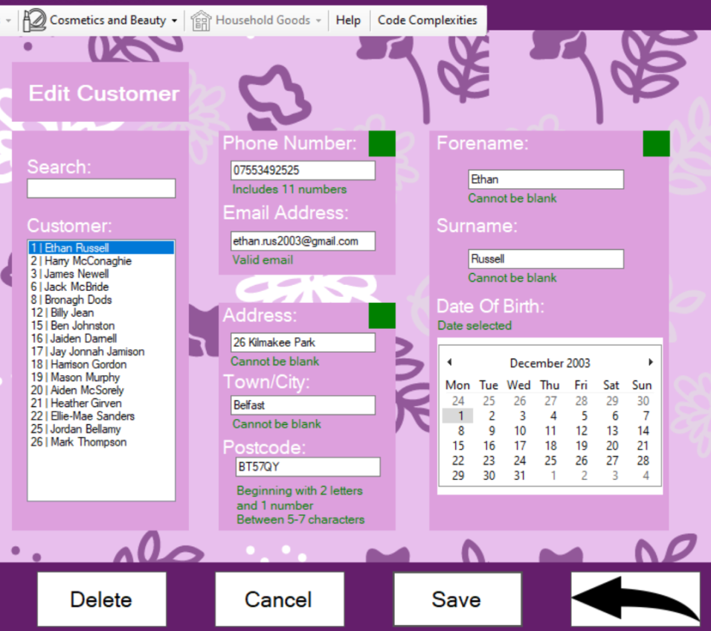

To the left you will see the complete list of customers and a search bar.

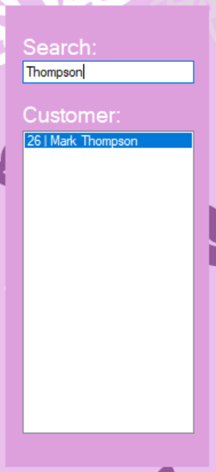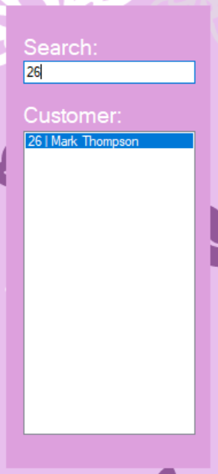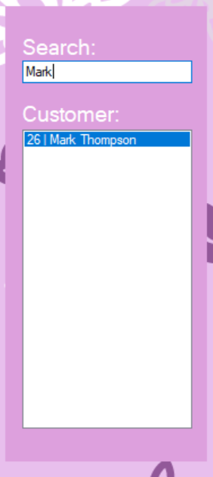

As you can see the search bar allows you to search for specific customers. It will allow you to search by the customer ID, forename and surname.

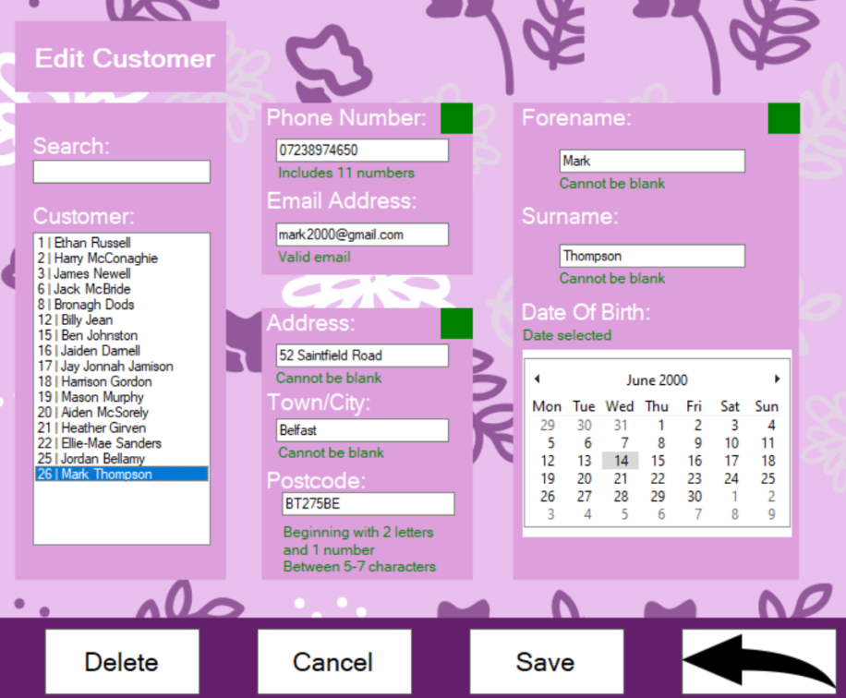

When a customer is selected it will display all the data in the respective field. This data can be edited as you see fit. The guidance labels still have to be adhered to.

“Forename” – Cannot contain numbers and special characters other than “-“and “.”

“Surname” – Cannot contain numbers and special characters other than “-“and “.”

“Date of Birth” – A minimum age of 13 is required

“Phone Number” –Only contains numbers and must be a length of 11 numbers

“Email Address” –Must contain an “@” symbol and a “.com” or “.co.uk”

“Address” – Cannot contain numbers and special characters other than “-“and “.”

“Town” – Cannot contain numbers and special characters other than “-“and “.”

“Postcode” –Must begin with 2 letters, followed by 1 or 2 numbers. Then it is followed by a combination of letters and or numbers. It Must be a length of 5 – 7 characters. It Does not accept spaces or special characters.

“Delete” – This will actually archive the customer. However there is no way to undo an archiving. This means that any bookings from the current date and onwards will be deleted and no new bookings for that customer will be able to be created.

“Cancel” – This will cancel any edits, returning the last saved data from the customer and disable the edit section of the form.

“Save” – This will save the data of the customer.

# Booking

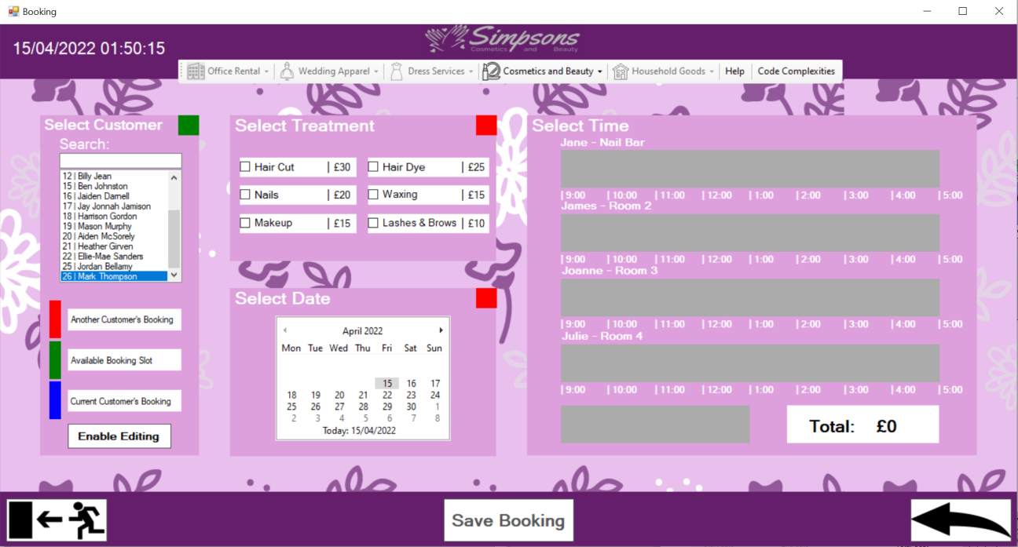This is the booking form where you can add and edit bookings for customers.

“Enable Editing” – This will enable the editing functionality of the form.

“Save Booking” – This will open the confirmation form showing summary information of the booking. It will enable when a booking has been placed on the tables.

## Add booking

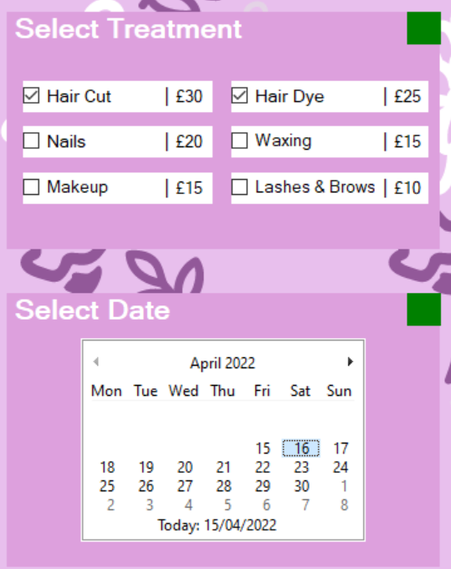Similarly to the edit customer you will begin by selecting your customer.

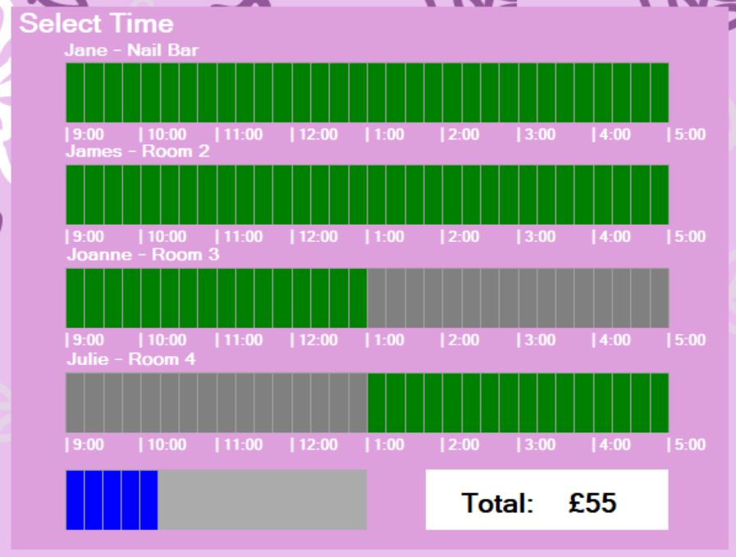

After you will then need to select your treatments and date. (These can be changed later) Choosing a date will populate the tables and allow you to select a time and see any other bookings for that day. As the key to the left would suggest the blue is the current selected customer’s bookings. The bottom displays the duration of the booking before it is placed. To the right you can also see the total.

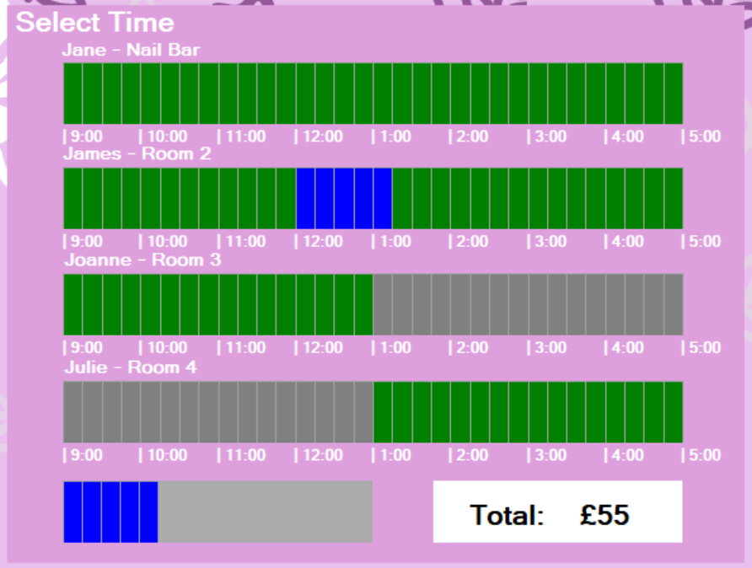

You can click on a time to set the booking. This can be changed as many times as you please. Clicking on the first rectangle of the booking will also remove it from the table.

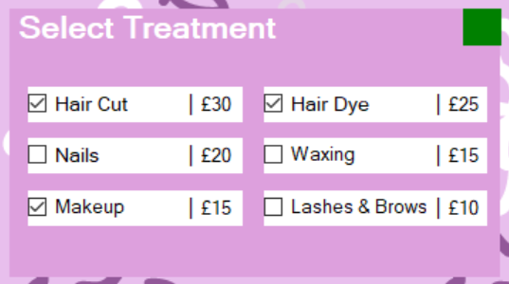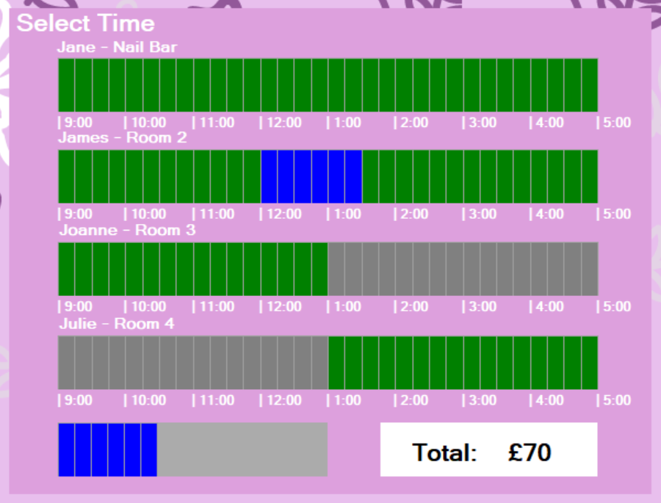

When choosing a time if you wish to select another treatment then it will update in real time.

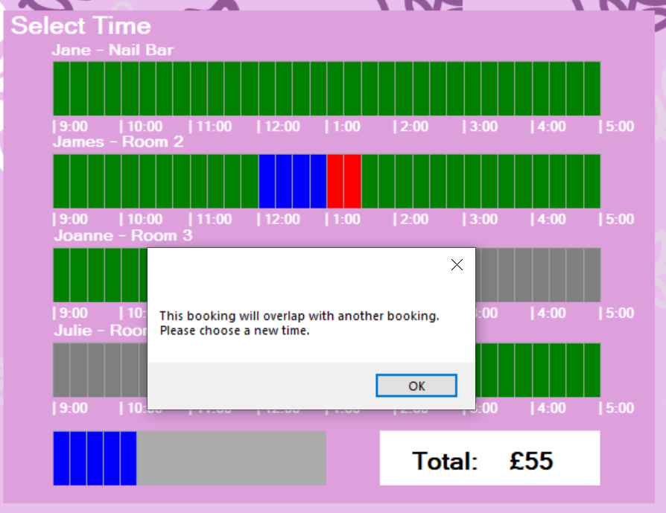

As the key to the left would suggest, the red is another customer’s booking. And as you can see you don’t need to worry about booking around other bookings as the system will warn you if there is an overlap and clear your booking from the table. The system will also not allow bookings to be booked for the same customer at the same time.

If adding another treatment caused an overlap then it will simply just deselect that treatment keeping the original booking.

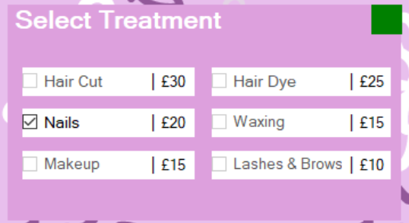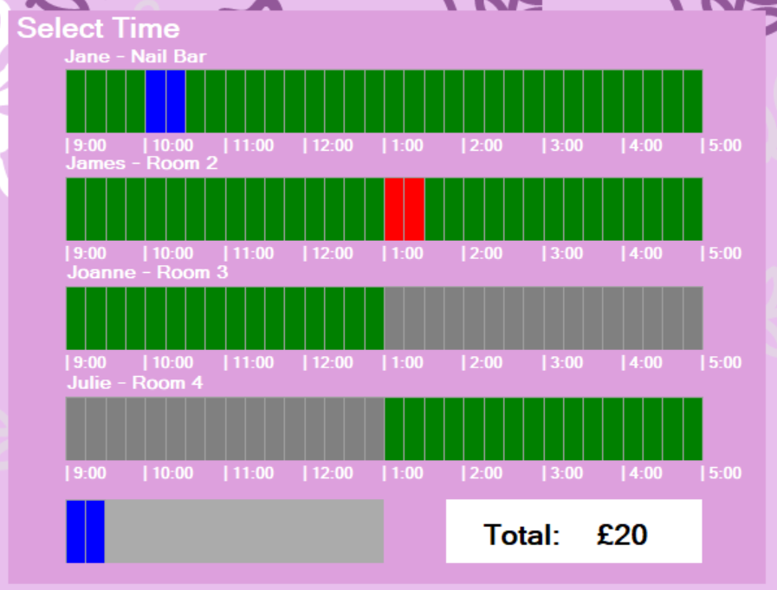

As you can see if you wish to book into the nail bar you must make a booking for nails. This will disable the other treatments for Jane. If you wish for other booking as well as nails you can make a separate booking at another time or select another therapist and room.

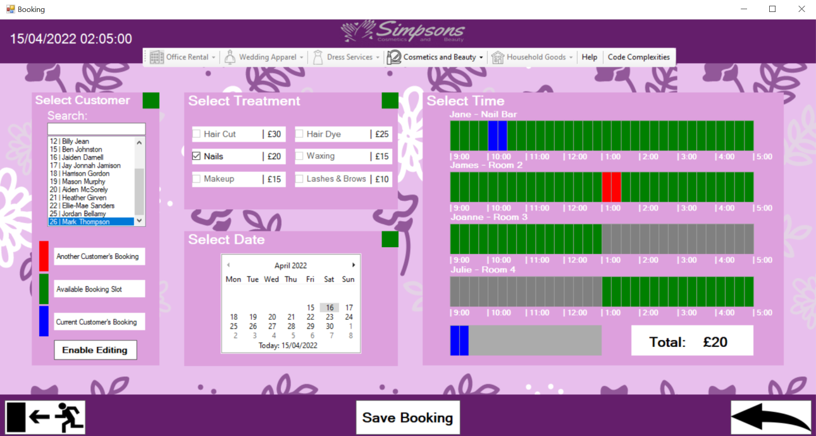

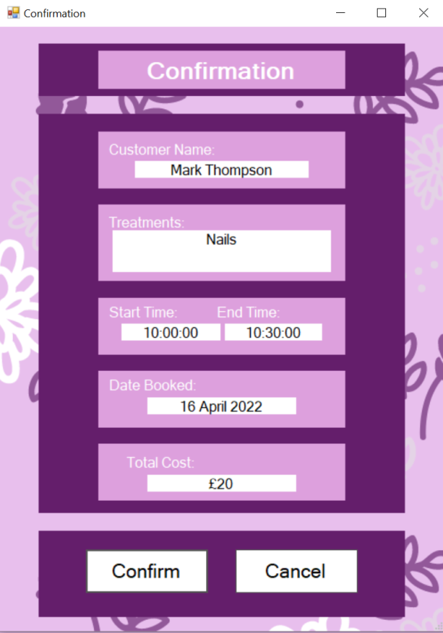This shows what a complete booking looks like. The save button is now enabled.

The confirmation form is opened when the save button is clicked. It shows summary information of the booking you wish to add.

“Confirm” – This will save the booking.

“Cancel” – This will bring you back to the booking form. The information of your booking will still be present on the booking form.

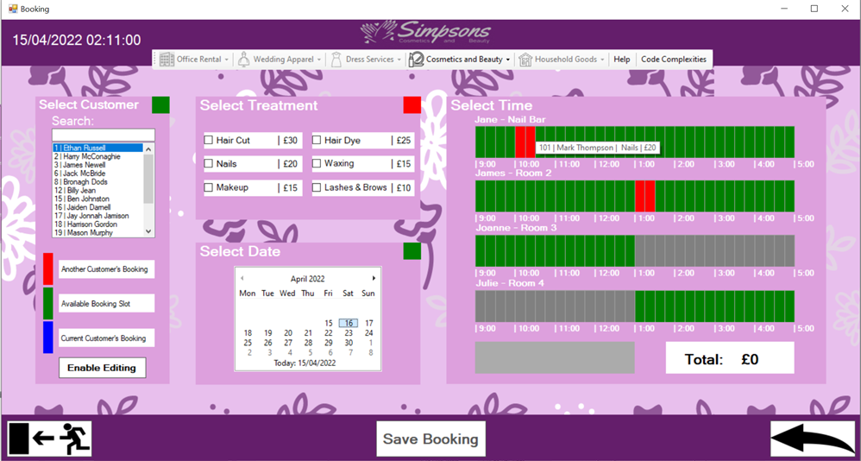

Your booking has now been added. The form will reopen on and automatically open on the last date saved. If you wish you can also hover over bookings to display some short summary information.

## Edit Booking

This will allow you to change any future booking and view all archived bookings.

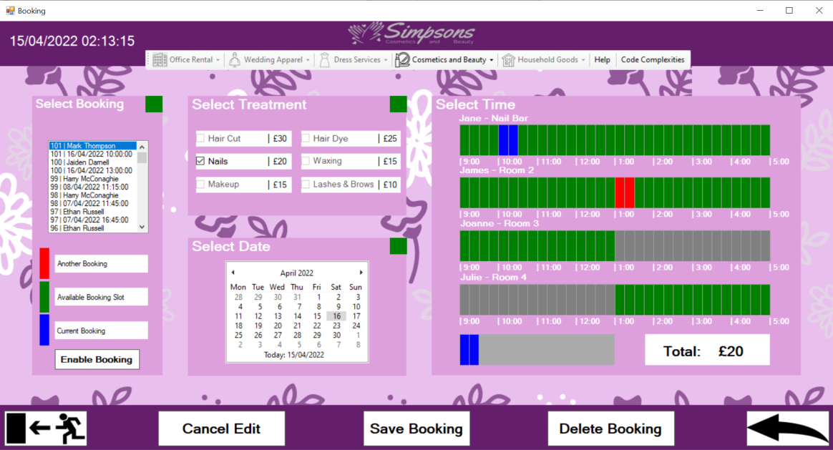

If the enable editing button is pressed it will switch the form to the editing side. As you can see you can now select a booking instead of a customer and it will act the same as when adding a booking. The key to the left has been updated to fit the edit functionality.

“Cancel Edit” – This will return the original data of the booking, cancelling any edits.

“Delete Booking” – This will permanently delete a booking. Only available for bookings booked on the current date and onwards.

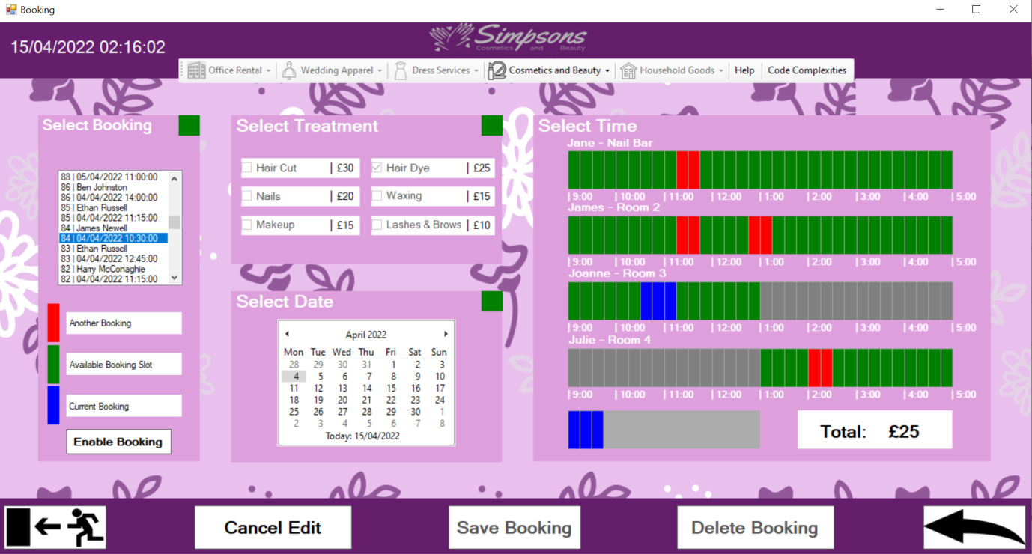

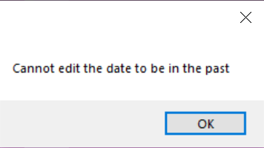An old booking may be selected from the list and it will automatically jump to that date and highlight the booking. Bookings can also be selected by clicking directly on the rectangles; this will highlight the booking as if you selected it on the list to the left.

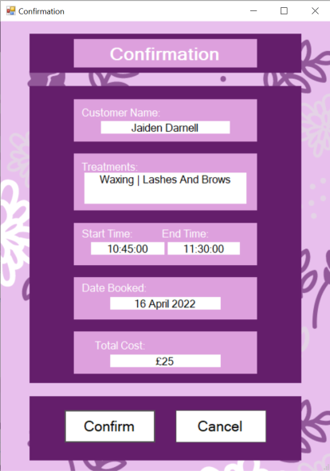When trying to edit a booking’s date into the past it will not allow you and return this message. Validations for adding a booking will still apply to editing a booking.

When saving an edit it will appear the same as when you are adding a booking.

# Reports

This will allow you to build a report for a certain customer.

*Note* If any new booking are made the system will need to be reopened if you wish to see it displayed on the report.

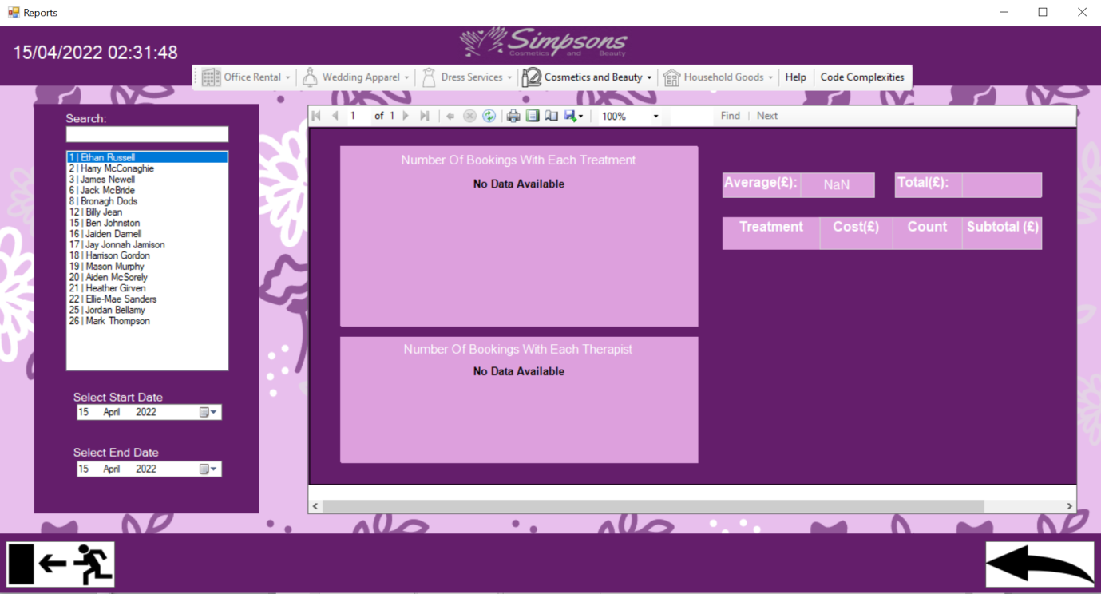

As you can see the report will automatically load. It will allow you to select a customer to the left and a choice of start and end date. Any change will automatically update the report.

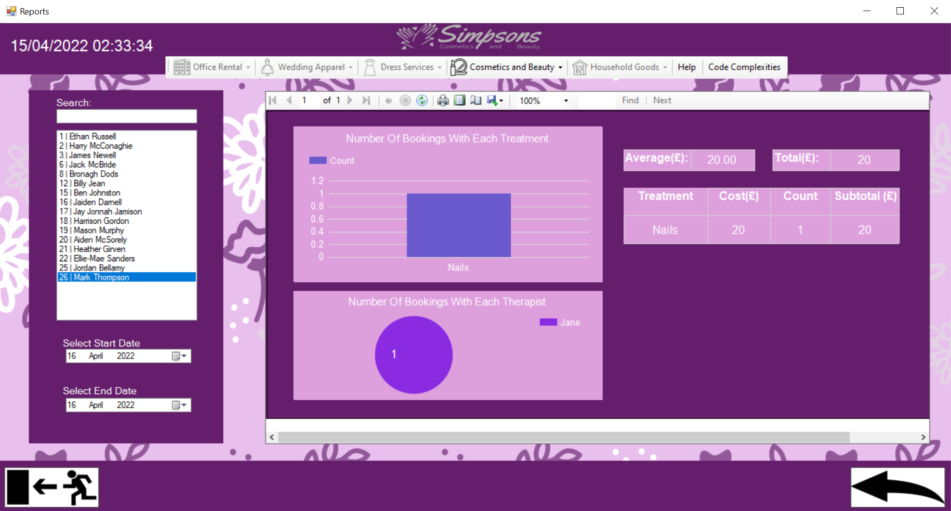

This is an example of a working report. As we saw previously there was a booking made for Mark to get his nails done with Jane on the 16th of April so we can confirm this is accurate.

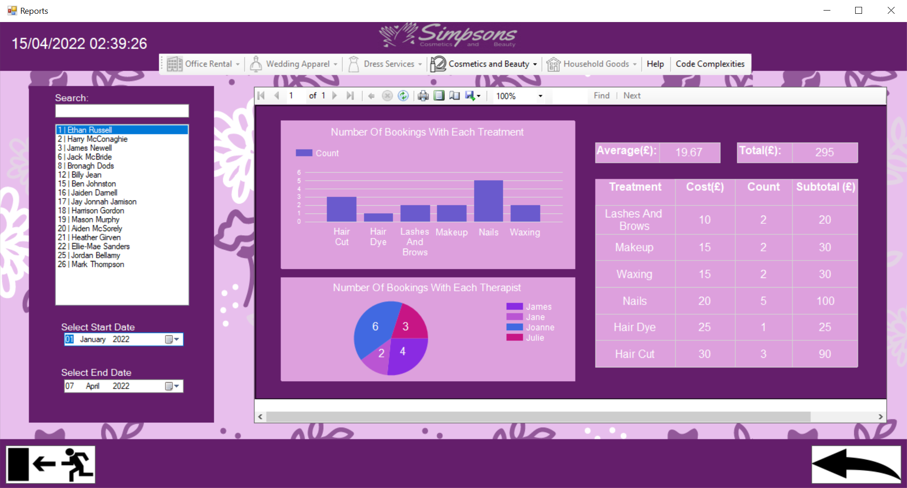

This is an example of a more full report. As we can see Ethan has fairly regularly made bookings. This shows the booked treatments and number of times booked for each treatment. As well as the distribution of therapists he has booked. To the right is also shows summary data for the treatments and amounts spent, as well as an average per booking.